If you use the Arduino IDE provided by us and open it in Chinese, you need to follow the following steps to switch to English.

1.After opening the Arduino IDE, you need to click【文件】--【首选项】 in the Arduino IDE menu bar, as shown in the following figure.

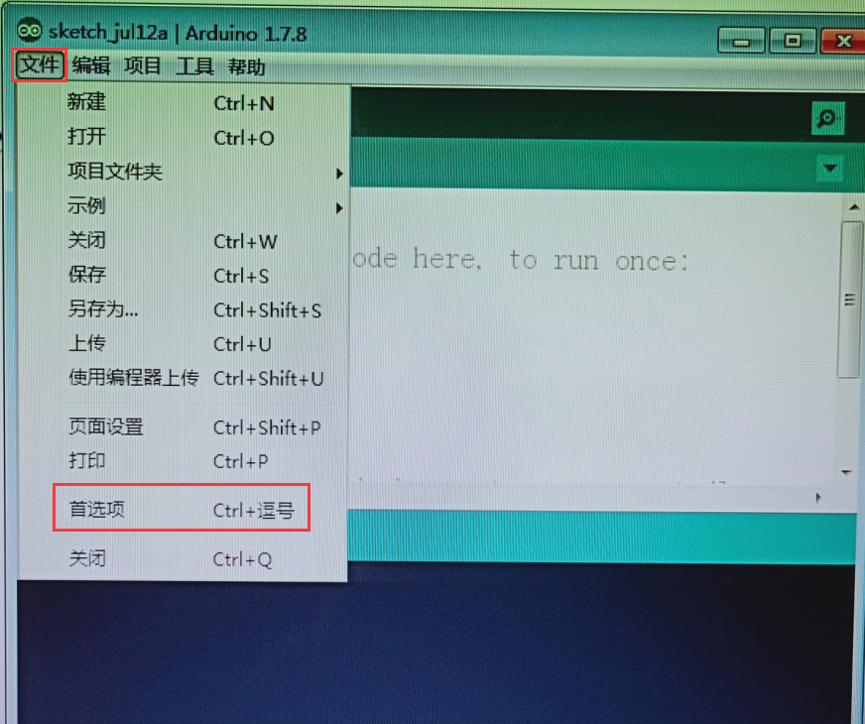

2.You need to click the editor language in the interface and select **English(英语)** and click “好”in the lower right corner, as shown in the following figure. You need to turn off the Arduino IDE and open it again.

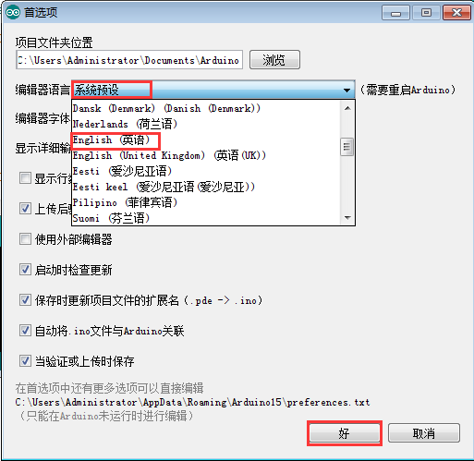

3.When you open it again and you'll find it in English, as shown in the following figure.

